How to turn on OPC for

TM View Enterprise 2.2

Abstract:
This document is intended as a guide to set up and turn on the functionality of the TMVE 2.2 OPC server. It is mostly intended to be used for systems on which OPC did not work in TMVEE 2.1, but is valid for all Win7 x64 systems.

Target Audience
The steps described below should be executed by personnel possessing some computer skills, and how are familiar with installing and troubleshooting TM View.

Assumptions:
- The user has already installed successfully TM View Enterprise 2.2
- The user must have administrator privileges

Procedure
- Make sure that the computer has all the Microsoft updates available: go to the “Start/All Programs/Windows Update” menu, and download then install all the priority updates available (skip the optional ones).
- Unzip the testOPC.zip into the folder C:\testOPC. It should contain the following folders:
  - Client
This contains a small OPC client used for testing.
  - LoadLib
This contains a small OPC server used for testing. This server auto-registers and un-registers.
  - Things To Install (this folder contains:
    - Folder OPC Core Components Redistributable (x86)
This folder contains the installer for the OPC core components for x86 applications.
    - Folder OPC Core Components Redistributable (x64)
This folder contains the installer for the OPC core components for x64
    - Vc_redist_86 VS2008 30729.17.exe
This is the installer for the C++ runtime libraries for the Microsoft Visual Studio 2008 C++ compiler.
  - The folder will also contain 2 shortcuts. These shortcuts are set to run as administrator: they will prompt the user to accept running them, and the user must have administrative privilege to do so, as below:
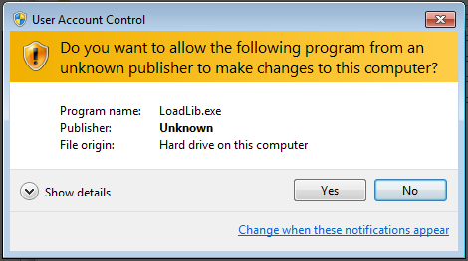
Figure 1 – User Account Control (UAC) prompt dialog box
- Verify that OPC is not working:
  - Double-click the “LoadLib Test” shortcut, click yes on the UAC prompt. The first time you run this, it could take a long time (more than a minute) for Windows to show the UAC window.
  - You should see a screen like below. The LoadLib test OPC server is a console application:
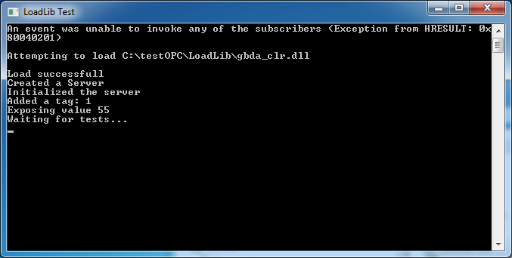
This is a test mini-OPC server, self registering, and self un-registering, as long as you follow instructions: do not use the red ‘X’ box to close this window, type Enter twice instead.
  - Leaving the console open, double-click the “OPC Client” shortcut, and approve the UAC prompt. The expected response is the “Cannot get to the type ‘OPC.ServerList.1’”.
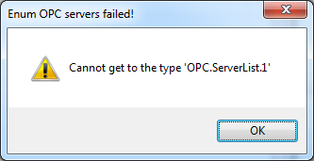
  - Click OK, and exit the OPC Client. Also, type <Enter> 2 times in the LoadLib Test window, so the LoadLib OPC server unregisters and goes away.
- Now we are going to install the components that will make it possible to register OPC and run an OPC client.
Open the “\testOPC\Things to Install” folder. It should contain the following items:
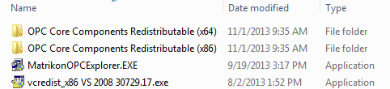
  - Double click the “vcredist_x86 VS 2008 30729.17.exe” application. This will install that version of the C++ run-time libraries. Answer all the prompts to install this package. It may take a while the first time. If this component has already been installed (it should have been installed by the TM View installer), choose “repair” or cancel out of this step.
  - Open the “OPC Core Components Redistributable (x86)”. Run the “Setup.exe” application. Same as above, if the package has already been installed, you will be prompted to select Remove or Repair. Select Repair.
  - Open the “OPC Core Components Redistributable (x64). Run the “Setup.exe” application. Answer all the prompts to install this package.
NOTE: if the package is already installed you will be prompted to either repair or remove this package. Choose “Repair”.
NOTE: skip this step if the host operating system is a 32-bits OS.
- Now we can test if the fix worked.
  - Run the LoadLib shortcut again, as in step 3 above. You should see the same thing as above, except that the client (step 3c) will succeed and find the OPC test server. You should see the following:
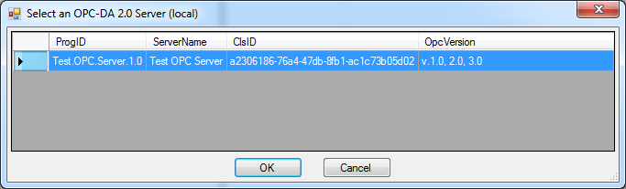
Select the Test OPC Server and click OK. You should now see the following screen:
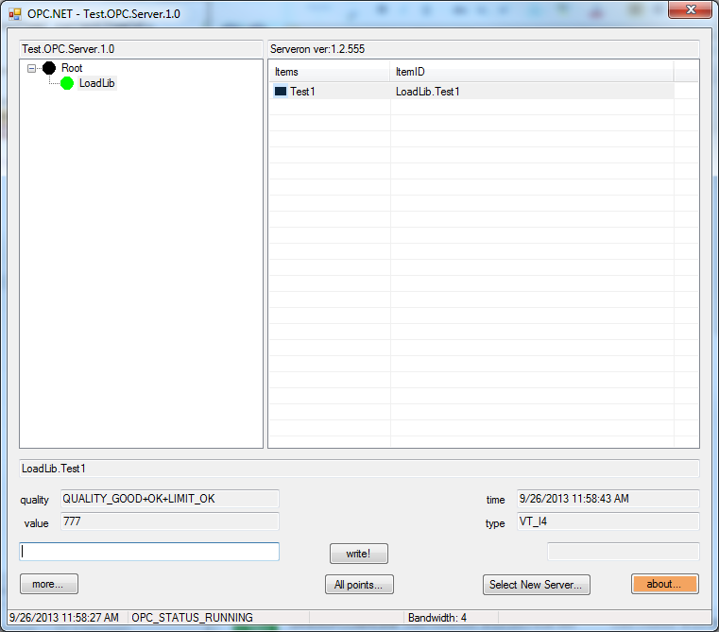
  - As a further test, type in the value “777” (or any other value you like better) in the console window. The response should be “Exposing value 777” and “Waiting for Tests…”
  - Extend the text by entering a new value in the textbox below value, next to the “write!” button, and click “write!” When you show the CMD window for the LoadLib application, you should see “Item 1 written with value XXX”, where XXX is the value you typed in the OPC client window.
This proves that there is bi-directional communication between the OPC client and the test OPC server.
  - Exit the OPC client (close the window).
  - Exit the test OPC server: type <Enter> twice in the console window for that application.
- We are now ready to register the TM View OPC server. That will require a restart of the TM View poller.
  - Open the Control Panel/Administrative Tools console, and select “Services”.
  - When the Services console opens, scroll down to the Serveron_Extended_Poller service, and stop the service.
  - Wait 30 seconds. Leave the Services console opened, we’ll need it again.
  - Open a command window as administrator: right-click on Start/All Programs/Accessories/Command Prompt (run as administrator).
- type in the command to change to the correct folder:
cd “C:\Program Files (x86)\Serveron\TM View Enterprise”
- type in the command:
“OPCRegistration.exe –service”
- The response should be “The operation was successful.”
- Verify further the results in the OPCRegistration.log file:
    - Open the folder C:\ProgramData\Serveron\TMView” and open the log file “OPCRegistration.log”.
    - The last entry should say “Serveron Poller OPC Server registered successfully”.
  - Back to the Services console, restart the Serveron_Extende_Poller service. Wait 10 seconds and click on the refresh button, checking that the service is still running.
- Now we can test the OPC client against the TM View poller OPC server.
  - Double-click the OPC Client shortcut in \TestOPC\. You should see a list of OPC servers including the Serveron.Poller.OPCServer:
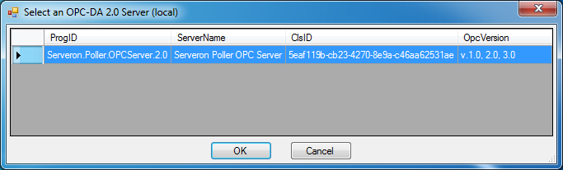
  - Select the Serveron Poller OPC server, and after a few seconds (depending on the number of monitors), you should see something like this:
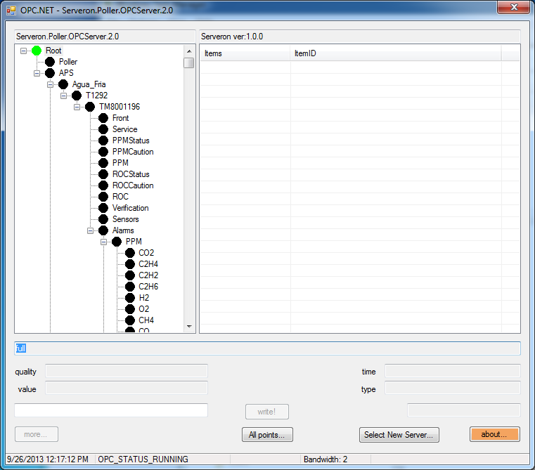
If you see something like this, then everything is working as it should, there is nothing else to do but use your normal OPC client.
Exit this procedure.

If there is no OPC server detected, or you have error messages from the OPC client, please collect all logs (in C:\ProgramData\Serveron\TMView) and screen shots as can be collected from the OPC client, and send these to Serveron support personnel.

